MIMANSA SOLANKI

MBA TECH IT

70411019055

Foreign markets serve as an important growth engine for western software companies. Google and Facebook both earned more than [**50%**](https://www.statista.com/statistics/266250/regional-distribution-of-googles-revenue/) of their revenue overseas. Microsoft, which provides enterprise-wide software solutions and cloud services, earned [**48.8%**](https://www.microsoft.com/investor/reports/ar20/index.html) of revenue outside the United States. Salesforce and Adobe, leading players in cloud-based software, earned [**30.6%**](https://investor.salesforce.com/press-releases/press-release-details/2021/Salesforce-Announces-Strong-Fourth-Quarter-and-Full-Year-Fiscal-2021-Results--Raises-FY22-Revenue-Guidance-to-25.65-Billion-to-25.75-Billion/default.aspx) and [**42%**](https://www.statista.com/statistics/1223429/adobe-revenue-region/) of their revenue abroad respectively.

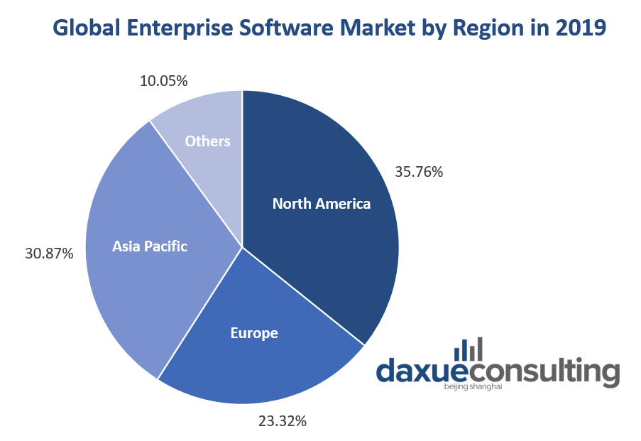

**Global software marketing strategies: What do successful global software companies have in common**

An easy-to-navigate user interface

Overly complicated software and long tutorials can turn customers away, even if they have many attractive features. Generally, the role of software is to simplify and expedite work processes. Most importantly, the software should communicate a clear goal and have a user-friendly interface that requires minimal explanation. Compared to Chinese netizens, westerners are more averse to digital clutter Therefore; a Chinese software product may have to simplify their user interface when catering to a western audience.

Dropbox, for example, has a clear goal and straightforward functions. It helps people store and manage files all in one place, allowing access from anywhere. Dropbox designed its website and apps that align with its slogan “get more work done in less time” through low-friction interfaces. In 2009 or one year after launch, Dropbox reached [**3 million**](https://gigaom.com/2009/11/24/dropbox-raises-7-25m-crosses-3m-users/) registered users.

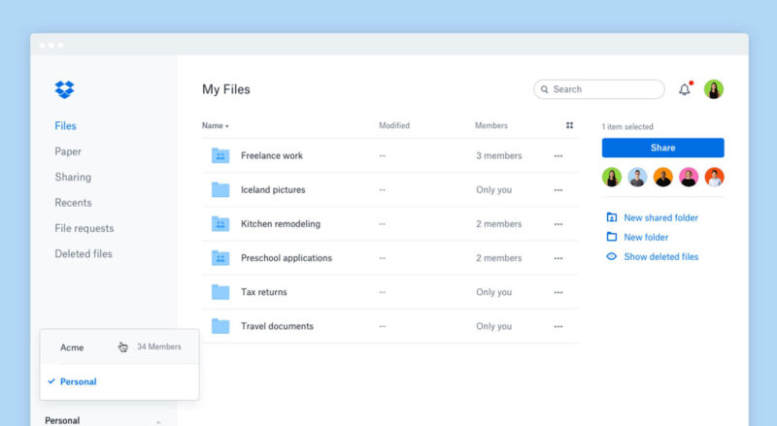

Software naming: The identity of a software

A name can influence the perception of a given software product or service. It is the first thing people see and what they will remember. For the international market, software names should be in English, easy to pronounce, memorable, and meaningful. For example, “TikTok” is a play on tick-tock, the sound of a clock or a term for countdowns, which relates to short videos on the platform. “TikTok” is also easier to remember than its Chinese equivalent “Douyin” for an international audience. A popular online game “Wangzherongyao” (王者荣耀) has an adaptation for the global market called “Arena of Valor”. Adobe “Photoshop”, Microsoft “Office”, and “Facebook” are simple names, yet they imply so much about their core functionalities.Software names such as “Strip”, “Slack”, “AWS”, and “Zendesk” all sound good on the tongue. Lastly, the name must be appropriate in any country or language.

When re-naming software for the international market, it is best to do brand-naming research and testing. Daxue consulting believes that a good brand name is 80% research and 20% creativity. This doesn’t limit the creativity of the name, rather focuses on what consumers are proven to be receptive to. Learn more about our [**process for brand naming**](https://daxueconsulting.com/brand-naming-china/).

The use of online channels to boost growth and brand outreach

Compared to traditional marketing channels, digital marketing offers software firms more value because of its effectiveness, cost reduction, quick feedback, and data. The following are common and effective digital software marketing strategies:

* Offering a free demo or trial version – people are more willing to pay for the software when they have tried it. A software demo or trial version allows potential users to experience the software themselves and understand its functionality and features; it can show how they can benefit from purchasing the software.
* Create content or a blog online – having useful and relevant information will not only attract potential customers to your website, but also make your brand trustworthy, increasing the chance of them buying your software product.
* Paid campaigns – established global software companies all invest in digital forms of advertisements, whether via search engines, other websites, or media platforms. Software firms can use online campaigns to educate people about their software, increase brand presence, and improve sales.

Customer support ensures long-term satisfaction and sustainable growth

A constant support pertaining to bugs, crashes, security, latency issues, and other usage problems is essential to keep customers satisfied and motivate them to continue using your software. Retaining customers is cheaper and more efficient than acquiring new ones. According to [**BCG research**](https://media.bain.com/Images/BB_Prescription_cutting_costs.pdf), a 5% increase in customer retention rate can raise profits by 25% all the way up to 95%. Acquiring new customers can cost [**five times**](https://www.invespcro.com/blog/customer-acquisition-retention/) more than retaining existing ones.

Shopify is an example of a company with exceptional customer support. The firm provides retailers and merchants with a suite of cloud-based services that helps them operate stores online. Shopify’s business model strongly emphasizes customer success. It has dedicated support teams that customers can reach 24/7 via phone, email, and live chat for help solving any technical problems. In 2020, Shopify earned [**$2.9 billion USD**](https://news.shopify.com/shopify-announces-fourth-quarter-and-full-year-2020-financial-results) and partnered with over [**1 million**](https://news.shopify.com/shopify-announces-third-quarter-2020-financial-results) businesses worldwide.

